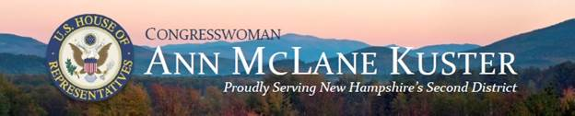

**Congresswoman Annie Kuster**

*Invites you to join her for*

**Farm Bill**

**Listening Sessions**

*An opportunity to share your thoughts on agriculture, nutrition, land conservation, forestry, rural development as Congresswoman Kuster and the House Agriculture Committee begin work on the 2018 Farm Bill*

|  |  |
| --- | --- |
| **Wednesday, August 16**  **UNH Cooperative Extension**  **315 Daniel Webster Highway**  **Boscawen, NH**  3:00PM – 4:30PM | **Tuesday, August 22**  **Dartmouth Organic Farm**  **100 Lyme Road**  **Hanover, NH**  11:00 AM – 12:30PM |

**Please RSVP to Sam Cooper-Wall**

Sam.Cooper-Wall@mail.house.gov or (603) 595-2006