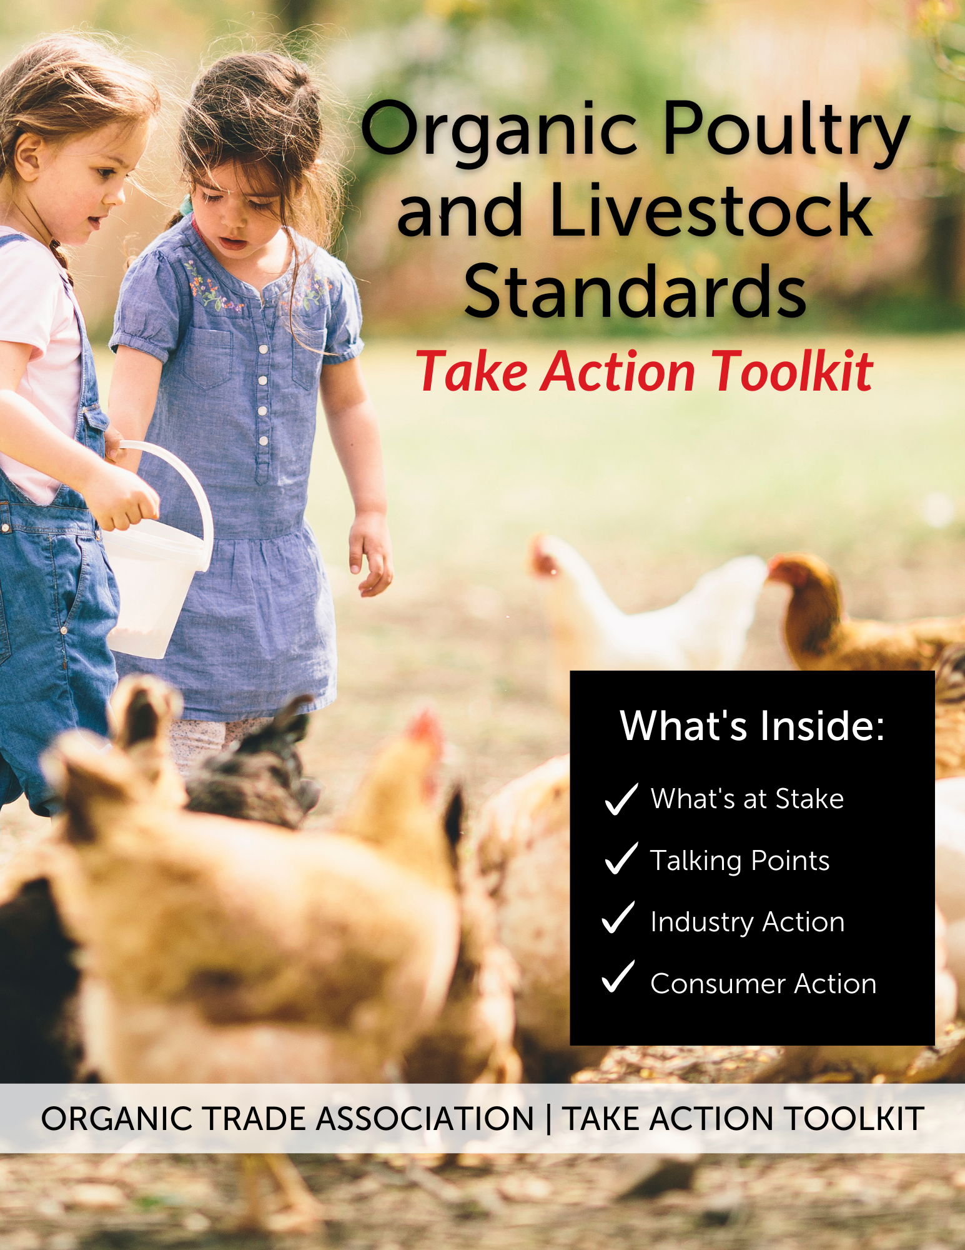

TABLE OF CONTENTS
- Organic Poultry and Livestock Standards: Summary and Background
- What’s at Stake?
- Talking Points
- Industry Action Toolkit
  - Comment Writing Instructions
  - Comment Template
  - Coalition Sign-on Letter
  - Poultry Producers Survey
- Consumer Action Toolkit
OUR ASKS
- Submit a custom comment directly to the Federal Register on behalf of your business or organization by November 10.
- Add your organization’s name to the coalition sign-on letter to USDA in support of the rule by November 10.
- Poultry producers and handlers complete our survey to inform OTA’s comments by September 21.
- Galvanize your network of consumers to drive individual comment submissions to the Federal Register. [Consumer Action Toolkit]
LINKS
- Consumer Comment Portal: VoterVoice
- Regulations.gov Comment Portal: Docket AMS-NOP-21-0073
- Background Information: ota.com/animalwelfare
CONTACTS
For communications and outreach support: Violet Batcha; vbatcha@ota.com; (315) 262-5990
For technical questions and comment support: Johanna Mirenda; jmirenda@ota.com; (202) 812-7704

Organic Poultry and Livestock Standards:
Summary and Background
The United States Department of Agriculture (USDA) released the Organic Livestock and Poultry Standards (OLPS) Proposed Rule and is currently seeking public comments through October 11, 2022 (Docket # AMS-NOP-21-0073). The long-awaited rule has strong support from the organic industry and is a serious step toward updating critical animal welfare provisions.
OLPS clarifies the production standards of avian and mammalian livestock as authorized by the Organic Foods Production Act (OFPA) to support consistent enforcement across producers and alleviate market failure by assuring consumers that USDA-certified organic livestock products meet a robust and uniform standard. The proposed rule:
- Clarifies living conditions, healthcare, transportation and slaughter practices to support animal welfare for mammalian livestock species.
- Establishes poultry indoor and outdoor space requirements and stocking density limits. Enclosed porches are not considered outdoor spaces.

Current USDA organic standards already require outdoor access and appropriate living conditions for poultry and livestock. Unfortunately, these regulations have not been consistently enforced, resulting in some large poultry companies utilizing narrow, enclosed porches instead of true outdoor access to meet this requirement. OLPS clarifies the standards for animal living conditions to require true outdoor access and room to roam for all poultry operations.
USDA has proposed two implementation periods (5 years vs 15 years) for certified egg producing operations to meet the outdoor space requirements for laying hens. We must take immediate action to 1) show the widespread industry and consumer support for the rule and 2) express the absurdity of the proposed 15-year implementation period and urge no more than 5 years.

What’s at Stake?
Health and competitiveness of family farms – inconsistent animal welfare standards for organic chickens create an unlevel playing field for organic farmers already providing true outdoor access.
Advancement of organic animal welfare – 75% of Americans are either very or somewhat concerned about the treatment of animals by the meat and dairy industry.
Consumer trust and integrity of the organic label – 89% of Americans say the USDA should periodically review and update the organic standards to keep pace with new science and consumer expectations.

INDUSTRY ACTION TOOLKIT

RESOURCES
- Comment Writing Instructions
- Comment Template
- Coalition Sign-On Letter
- Poultry Survey

COMMENT WRITING INSTRUCTIONS
- Write your own unique comment using our key talking points or our fill-in-the-blank template on the next page. The template is fully editable, so copy the text into your own word document, fill in the blanks as appropriate, and delete any text that isn't relevant to your operation.
- Submit your written comment to the USDA through the Federal Register e-portal (Docket AMS-NOP-21-0073) by November 10 at 11:59 p.m. ET. Word documents or PDF’s can be attached (no page limit). Comments may also be submitted by mail to: Erin Healy, MPH, Director Standards Division, National Organic Program, USDA-AMS-NOP, Room 2646-So., Ag Stop 0268, 1400 Independence Ave. SW, Washington, DC 20250-0268.

Key Talking Points
- I support the Organic Livestock and Poultry Standards Rule to strengthen organic animal welfare standards, create greater consistency among organic producers and certifiers, and meet consumer expectations for organic livestock products.
- I support true outdoor access for all organic livestock. The proposed clarification that enclosed porches do not meet the outdoor access requirements for poultry will level the playing field for producers and help eliminate consumer confusion about the meaning of the USDA organic label.
- Consumer trust and confidence in the USDA Organic seal are the foundation of our industry. Consumers are willing to pay a premium for expected animal welfare standards. Not meeting expectations in this area of the standard puts consumer trust in the USDA seal at stake and it will have long-term detrimental effects on the entire industry.
- Organic is a choice. The voluntary National Organic Program relies upon regulations that are consistent, clearly enforced, and renovated over time. Market demand for organic is driven by the distinction and differentiation that the standards provide.
- Clear regulations are necessary to fix market failure. A vast majority of organic farms and businesses are already meeting the standard. Without the clarifications in the proposed rule, these organic producers will continue experiencing a direct competitive disadvantage and be forced to add unnecessarily duplicative third-party certifications to differentiate their products.
- Timely implementation is critical. The excessively long 15-year implementation option is unacceptable as it would amplify the existing consumer confusion and market failure that USDA acknowledges in the proposed rule. Poultry operations certified at the time of the final rule’s publication date should have no more than 5 years to comply, and new entrants must comply within 1 year.
Comment Submission Instructions
- Follow this link to Federal Register (Docket # AMS-NOP-21-0073)
- Write a comment into the comment box or upload your comment as an attached file
- Provide your email address in the prompt
- Identify whether you are an individual, an organization or anonymous
- Do the test to confirm you are not a robot
- Submit your comment
- If you are successful, you will receive a comment tracking number. Save it for reference.
Hint: To calculate your egg productivity rate
- Count the total number of eggs you get from a hen at 78 weeks of total bird age (Example: 340 eggs/hen)
- Divide by 12 (Example: 28.33 dozen eggs per hen)
- Divide by 60 weeks of laying (Example: 0.4722 dozen eggs per hen per week)
- Multiply by 52.143 weeks in a year (Example: 24.62 dozen eggs per hen per year)

COMMENT TEMPLATE
Erin Healy, MPH, Director Standards Division
National Organic Program, USDA-AMS-NOP
Room 2646-So., Ag Stop 0268 1400 Independence Ave. SW, Washington, DC 20250-0268.

Re: Organic Livestock and Poultry Standard Proposed Rule

Docket: AMS-NOP-21-0073

Dear Ms. Healy,

I am a USDA-certified organic operation and I support the Organic Livestock and Poultry Standards (OLPS) Rule to strengthening the animal welfare standards for organic livestock production, create greater consistency among organic producers and certifiers, and meet consumer expectations for organic livestock products.

[Describe your business: name, location, types of organic livestock products, years certified, size/scope of production.]

Consumer trust and confidence in the USDA Organic seal are the foundation of our industry. Consumers place trust in the organic label to deliver on the values that are important to them, and their families and are willing to pay a premium for expected animal welfare standards. Not meeting these expectations puts consumer trust in the USDA seal at stake and it will have long-term detrimental effects on the entire organic sector. The OLPS Rule will support consumer confidence and market demand by providing standards that more closely align to consumer expectations.

Organic is a choice. The voluntary USDA organic standards have always called for outdoor access in response to market demand for organic production. Organic producers voluntarily enter the organic market with the understanding that the rules will evolve over time and that their practices will need to adjust according to market demands. The viability of the
organic market rests on the trust that the organic seal represents a meaningful differentiation from other agricultural practices. A federal voluntary standard that meets the changing needs of customers is imperative for the organic sector. Without the ability to deliver a product that keeps up with the evolving consumer preference and market demand, the relevance of the USDA Organic seal is at stake. The OLPS Rule will support an open, fair, and equitable market for all producers who choose to pursue organic certification.

The OLPS Rule is necessary to reduce consumer confusion and fix market failure. The USDA is correct that market failure exists, and that the existing organic livestock regulations have been inconsistently applied across producers and certifiers. For example, a vast majority of organic livestock operations are already meeting the proposed standards for outdoor access while some are only providing enclosed porches. Without the clarifications in the proposed rule that enclosed porches are not outdoor access, many organic producers will continue experiencing a direct competitive disadvantage. Clarifying the animal welfare rules for organic livestock will create a level playing field and support fair competition among producers by facilitating consistent certification and enforcement decisions for all producers. The OLPS rule will also reduce consumer confusion about the meaning of the organic label as it applies to livestock living conditions by providing standards that would apply to all organic livestock operations and reducing the need for additional private animal welfare certifications. Based on my organic operation, the benefits of the OLPS Rule far outweigh the costs and will bring invaluable benefits to farm animals, farming operations, and consumers.

[Explain how your organic business has been negatively impacted by unclear standards, inconsistent enforcement, economic disadvantages, consumer confusion, and/or the need for additional animal welfare certifications.]

[Explain the reasons that the rule will benefit your organic business in terms of consumer confidence, meeting consumer expectations for outdoor access, reduce need for add-on labels, and/or competitiveness in the marketplace.]
Timely implementation of the OLPS final rule is critical. USDA acknowledges in the proposed rule that current conditions are causing consumer confusion and market failure. The excessively long 15-year implementation option is unacceptable because these negative conditions would be amplified over time. The Rule is long overdue and is critical to ensure continued trust in the USDA Organic seal and a level playing field for all organic livestock and poultry producers. USDA needs to move expeditiously to develop a final rule based on public comments. The final rule should be effective as soon as legally possible. Poultry operations certified at the time of the final rule’s publication date should have no more than 5 years from the effective date to comply with new outdoor space requirements concerning stocking density, exit doors, soil, and vegetation. Poultry operations certified after the final rule’s publication date must comply within 1 year of the effective date, provided that accommodations are made for new operations to complete transitions already approved by their certifier.

[Optional paragraph for poultry producers with mortality lower than 8%. Fill in the blank, specify broiler or layer, add any other information that disproves outdoor access increases mortality. Include cage-free comparison if applicable.]
The underlying assumption that bird mortality increases as a result of outdoor access is incorrect. The USDA's economic analysis estimates that the mortality rate of birds managed under the OLPS Rule will increase to 8% (from 5%) as a result of the new requirement for outdoor access. However, mortality rates for organic flocks at my operation is _________. For comparison, my operation also raised non-organic Cage Free flocks and the mortality rate is _________. Increasing the mortality rate to 8% is not in line with the data on my operation.

[Optional paragraph for egg producers with data on feed conversion rates. Fill in the blank and add any other details about your production practices that disprove outdoor access increases feed cost.]
The underlying assumption that feed costs increase as a result of outdoor access is incorrect. The USDA's economic analysis assumes an increase in feed costs per bird due to increased energy expenditure outdoors and estimates the feed conversion rate would move from the baseline 3.8 pounds per dozen to 4.0 pounds per dozen as a result of the new requirement for outdoor access. However, feed conversation rates for organic flocks at my operation is _________. Increased feed costs is not in line with the data on my operation.

[Optional paragraph for egg operations with egg productivity higher than 25.66 doz eggs/hen/yr. Fill in the blank and add any other details about your production practices that disprove outdoor access decreases egg productivity.]
The underlying assumption that egg productivity decreases as a result of outdoor access is incorrect. Productivity for organic layers on my operation is _____dozen eggs per laying hen per year. Reducing the productivity rate less than this is not in line with the data on my operation.

Sincerely,
<Name>
<Title>
<Company>
COALITION SIGN-ON LETTER
Add your name to the following sign-on letter that will be delivered to USDA in support of the rule and a swift implementation period. All farms, businesses, and organizations are invited to sign-on to Coalition Letter by October 4, 2022. Sign-on here.
The Honorable Thomas J. Vilsack
Secretary, U.S. Department of Agriculture
Jamie L. Whitten Building
1400 Independence Avenue, SW
Washington DC, 20250

Docket: AMS-NOP-21-0073

RE: National Organic Program; Organic Livestock and Poultry Standard Proposed Rule

Dear Secretary Vilsack,
Thank you for the opportunity to provide feedback on the USDA National Organic Program’s proposed rule on Organic Livestock and Poultry Standards (OLPS). We strongly support this rule and your leadership in advancing animal welfare standards for organic livestock during your tenure at USDA spanning multiple administrations. Issuing a final rule on OLPS will improve animal health, strengthen consumer confidence in the organic label, and ensure clear, consistent, and enforceable regulations for the organic livestock sector. Requiring all certified organic livestock operations to meet the same standard will reduce competitive harm in the marketplace.
The OLPS proposed rule will create clear standards for outdoor access for organic poultry, set minimum indoor and outdoor space requirements for poultry, and further clarify living conditions, healthcare, transportation, and slaughter practices to support animal welfare for all organic avian and mammalian livestock species. Most importantly, the rule will clarify that screened-in, enclosed porches do not qualify as sufficient outdoor space for organic poultry. This proposed rule is long overdue and reflects more than a decade of input from stakeholders, which is why we support a swift implementation timeline of no more than five years for currently certified operations to comply.
Outdoor access has always been a core tenet of organic livestock production. The organic regulations require certified organic livestock farms and businesses to provide year-round access to the outdoors, shade, shelter, exercise areas, fresh air, clean drinking water and direct sunlight for all livestock. Producers are also required to create an environment that allows animals to express natural behaviors and implement preventative healthcare practices to reduce the likelihood of illness. In 2010, USDA issued a final rule that created clear standards for grazing and access to pasture for organic dairy and cattle. The OLPS rule further advances animal welfare by doing the same for organic poultry.
The Organic Foods Production Act grants USDA authority to set federal standards for the production and handling of all organic products certified to the USDA Organic label in order to facilitate interstate commerce. As a voluntary regulatory program, having clear, consistent and enforceable standards is paramount for the organic sector to not only maintain consumer trust but to ensure that farms and businesses of all sizes have a fair shot of competing in the marketplace by meeting a minimum set of standards. We agree with USDA’s assertion that the lack of clarity on outdoor access requirements for organic poultry has created competitive harm and market failure for the organic egg sector. The OLPS proposed rule will create a more level playing field and expand market opportunities for organic dairy, meat, poultry, and eggs which make up 15% of the overall organic market with a current value of nearly $10 billion.
Lastly, finalizing the OLPS rule will help maintain consumer confidence and trust in the USDA Organic seal. Recent research commissioned by the Organic Trade Association shows that 75% of Americans are concerned about the treatment of animals by the meat and dairy industry. Animal welfare and outdoor access are core value propositions for organic shoppers, and they are willing to pay more for these benefits. 87% of consumers expect the organic standards to be updated to reflect evolving understandings about soil, climate, health, and animal welfare. The implementation of this rule is critical to reduce consumer confusion in the marketplace and increase consumer trust in organic. If consumers can’t feel confident that the organic eggs they purchase come from chickens that have access to pasture, they will continue to seek other third-party private certifications outside of organic and question the value of the organic label, harming the entire sector.
Organic represents one of the fastest-growing food and farming sectors in the U.S. and global marketplace, reaching over $63 billion in U.S. annual sales. The benefits of organic are numerous. Organic provides economic opportunities for farmers, creating jobs and lifting rural economies, while also utilizing sustainable farming practices that are proven to help mitigate the threat of climate change. Organic provides a safe, healthy choice to consumers, who are increasingly seeking out the trusted USDA Organic seal on the food and products they purchase for their families. Again, we strongly support the Organic Livestock and Poultry Standards proposed rule and urge its swift implementation.

POULTRY SURVEY
This survey is to gather organic poultry data to support the Organic Livestock and Poultry Standards (OLPS) rule and is open to any NOP-certified producer or handler of egg layers or broilers. Please complete the survey by September 21, 2022.

This survey is administered by the Organic Trade Association (OTA). Your responses will be held confidentially by OTA staff. Responses will be compiled into a summarized, anonymous format and communicated to USDA as part of OTA’s public comments on the OLPS Proposed Rule. If you have questions about this survey or results, please contact Johanna Mirenda, jmirenda@ota.com 202-812-7704.

CONSUMER ACTION TOOLKIT
Use the resources provided to galvanize your network of consumers through social media, your email list, and on-package or in-store QR codes to support animal welfare by submit individual comments to the Federal Register supporting OLPS and a swift implementation period.
Consumer Comment Form: https://www.votervoice.net/OTA/Campaigns/95316/Respond
Campaign Hashtag: #ChickensBelongOutside

RESOURCES
- QR Code
- Website Embed Code
- Sample Social Language
- Sample Social Graphics + Videos
- Template Email

QR CODE
Please use the following QR code by printing and placing it on packages, in-store shelves, bulletin boards, or retail/grocery spaces. Phones can scan the QR code to access the consumer comment form. Contact Violet Batcha (vbatcha@ota.com) if you would like QR code graphics or flyers created for your use.
(Download QR code here)
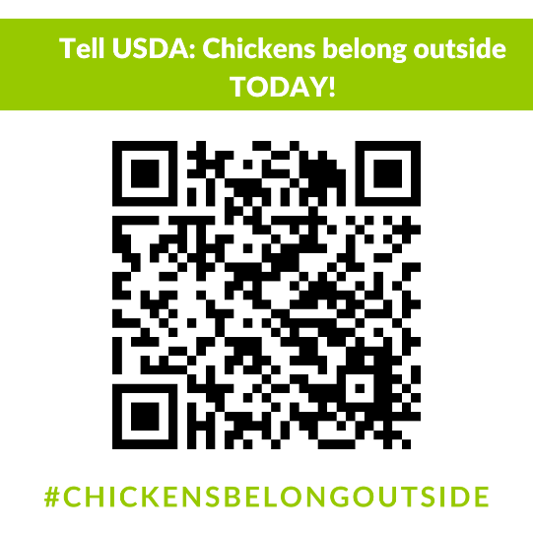

WEBSITE EMBED CODE
Add the consumer comment form directly onto your website using the following embed code:

<script src="https://www.votervoice.net/Scripts/Fw4AAAAAAAA/Plugin.js?app=campaigns&id=95316"></script>

SAMPLE SOCIAL LANGUAGE
1. Instagram/Facebook/LinkedIn
Nobody likes being cooped up, not even chickens! Due to a loophole in the USDA Organic regulations, however, millions of organic chickens are cooped up. Organic chickens belong outside in the sun and pasture. You can help ensure that organic chickens have room to roam and that the organic eggs and meat on your family’s table always comes from farms with the highest animal welfare standards by contacting the U.S. Department of Agriculture today! Submit your comment here https://bit.ly/3zW8Xl8 by clicking the link in our bio! #ChickensBelongOutside
2. Twitter
Organic chickens belong outside in the sun and pasture. Take action TODAY, tell USDA to advance the Organic Livestock & Poultry Standards rule and close the regulatory loophole that keeps millions of organic chickens cooped up! #ChickensBelongOutside https://bit.ly/3zW8Xl8

SAMPLE SOCIAL GRAPHICS AND IMAGES
The compiled images below are for you to share on social media outlets such as Instagram, Twitter, Facebook and LinkedIn. We have created these images in both square and rectangular sizing. Don’t forget to use the hashtag #ChickensBelongOutside and link to the consumer comment form.
Contact Violet Batcha (vbatcha@ota.com) if you would like custom images created for your use.
(Download square and rectangle versions of the images below here)
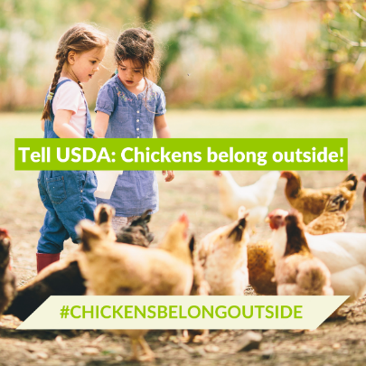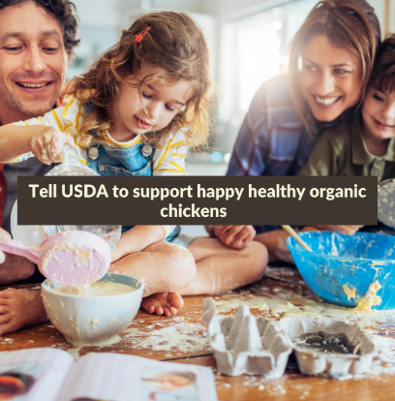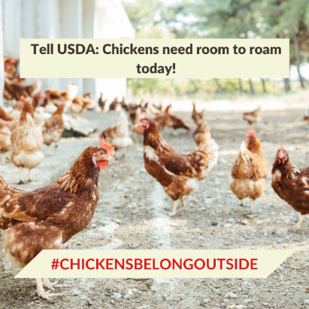
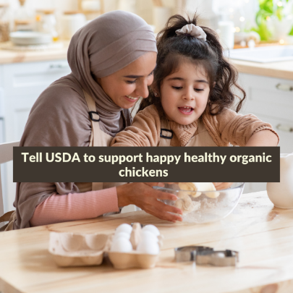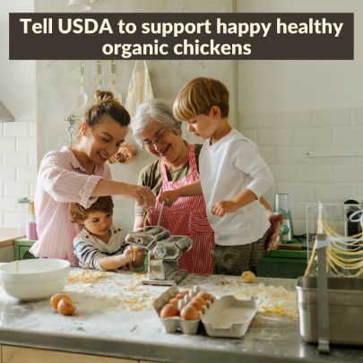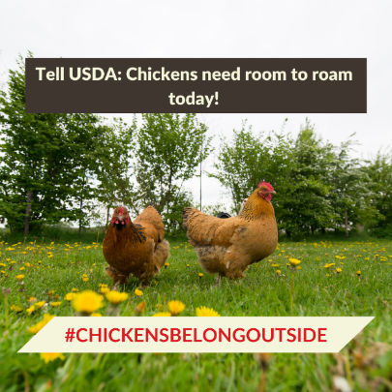
These compiled videos below are for you to upload on your social media platforms. Don’t forget to use the hashtag #ChickensBelongOutside and link to the consumer comment form.
How to attach a link to your Instagram Story:
1.Upload content to your story.
2. Select the sticker tool from the top navigation bar.
3. Tap the “Link” sticker to add your link and tap “Done.”
(Please find these videos available for download in landscape and portrait here)
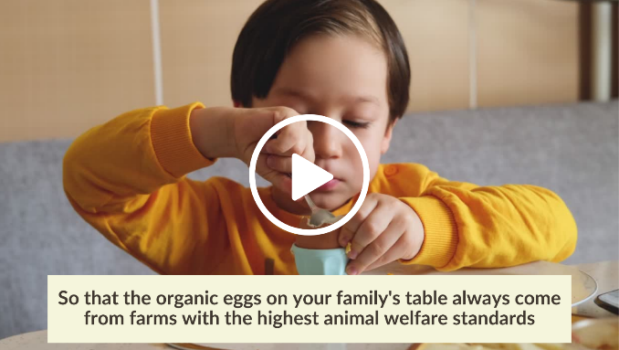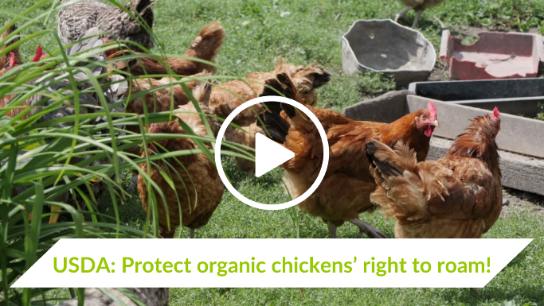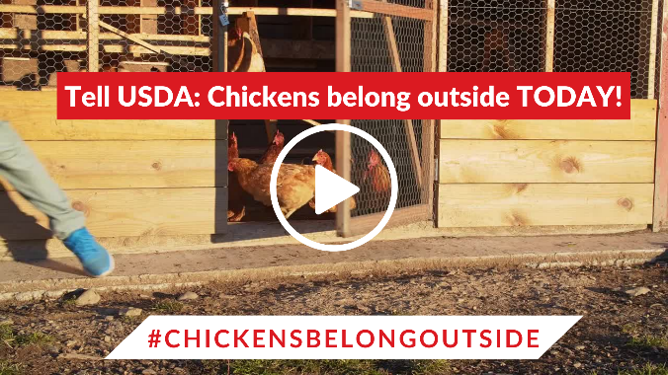

EMAIL TEMPLATE
Please share the following email messaging to your consumer email list.
SUBJECT LINE: Take Action! Organic Chickens Deserve Outdoor Access and Room to Roam
[First_Name],
Nobody likes being cooped up, not even chickens! Due to a loophole in the USDA Organic regulations, however, millions of organic chickens will stay cooped up – unless you join us in telling USDA to pass an Organic Livestock and Poultry Standards (OLPS) (aka the animal welfare) rule that will ensure ALL organic chickens have outdoor access and room to roam.
Take action to ensure all organic chickens have room to roam!
You might be wondering, doesn't USDA already require that organic chickens be given outdoor access? The answer is, yes! The organic regulation states that all certified organic operations must give their animals “access to the outdoors, shade, shelter, exercise areas, fresh air, clean water for drinking, and direct sunlight.” Unfortunately, these regulations have not been consistently enforced, resulting in some large companies utilizing narrow, enclosed porches instead of true outdoor access to meet this requirement. This practice has led to inconsistent animal welfare standards for organic chickens and an unlevel playing field for all the organic farmers who treat their birds right.
USDA is currently seeking public comments on animal welfare standards for organic poultry and livestock, and we need YOU to join tens of thousands of organic advocates across the country in demanding that organic chickens have room to roam – both inside and outside of the barn. Don't let millions of organic chickens stay cooped up one day longer, tell USDA to finalize the organic animal welfare final rule that will ensure ALL organic chickens have permanent access to true outdoor conditions!
Thank you,
(Organization Name)

